Dickens, Racism, and Chauvinistic Madness
Mitsuharu MATSUOKA

Comparing certain of Dickens’s characters with those created by his occasional collaborator Wilkie Collins, Maria K. Bachman observes: “Unlike Dickens, Collins explores the inner psyches of his mental deviants, examining what it means to be cast as ‘other’ and relegated to the margins of society in Victorian England.”¹ It could be safely said that some of Dickens’s darker stories, such as “A Madman’s Manuscript” in The Pickwick Papers and “The History of a Self-Tormentor” in Little Dorrit, are actually of equal psychoanalytic value. Yet it is probably true that Dickens is generally better at representing warped psychology and its roots in authoritarianism and worship of the powerful than he is at portraying marginal people driven into marginal environments. While he could see more clearly than most the flaws at the heart of his society—was willing to expose some of them—he seems to have less clearly perceived the edges or beyond, and his works increasingly suggested a hesitancy to venture out there.
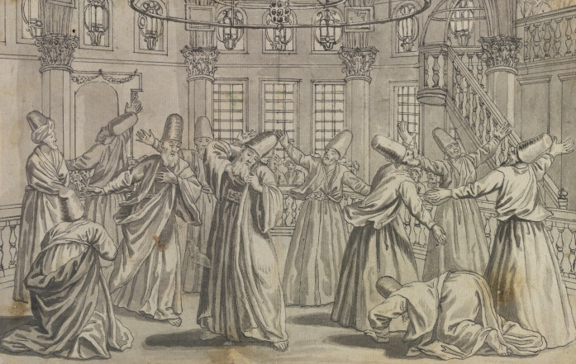

Figure 1: “Whirling Dervishes” (ca. 1725-50), drawn by Jean-Baptiste Vanmour.

His last collaboration with Collins was “No Thoroughfare” (1867), in which Joey Ladle, the head cellarman of Wilding & Co., regards all the performers at the Wednesday concerts established for the patriarchal family as “a set of howling Dervishes” (act 1, ATYR, Christmas No., 1867). Originally, the word dervish referred to the Moslem equivalent of a monk or friar frantically performing such acts of ecstatic devotion as whirling dances (Figure 1). Later, the word came to be associated in Britain with any kind of wild behavior that suggested emotions spinning out of rational control. In fact, beneath the expression used by Ladle there lies that colonialist perspective which readily views other races, and foreign culture beyond its comprehension, as bordering on insanity. At the same time, such judgments could be seen to constitute an unconscious projection of a deep-seated sense of insecurity onto some feared and despised other. The racial chauvinism beneath Ladle’s viewpoint was common among Victorian people, and is typified in Dickens’s Mr. Meagles, who has “a weakness which none of us need go into the next street to find” (LD, bk, 2, ch. 17). Mr. Meagles obviously owes his name to measles, a highly contagious infection, and everybody’s weakness in Little Dorrit is in part a consequence of the social disease of inherent chauvinistic madness entrenched in Victorian England. Through Mr. Meagles, Dickens exposes the hypocritical and self-delusionary bigotry which buttressed that society’s apparent self-assuredness.
It is worth examining, however, the extent to which Dickens, as a citizen of that society, albeit a sometimes critical voice, manifested the same weaknesses of chauvinism and cultural insularity as his characters. In Little Dorrit, for example, a certain superciliousness is evinced in the narrator’s description of John Baptist Cavaletto’s distinctively Italian emphasis in speech as reflecting “a vehemence that would have been absolute madness in any man of Northern origin” (LD, bk. 2, ch. 22). Sabine Clemm claims that the weekly magazine Household Words, of which Dickens was an editor, “views Ireland as a colony of the British Empire, but the Irish actively resist colonisation and reject the subject status that is imposed on the natives of other colonies.”³ Dickens appears to have concurred with that colonialist view. In “On Duty with Inspector Field” (HW, 14 June 1851), a vivid account of a nocturnal visit to the London slums with the eponymous inspector, Dickens describes the poor London Irish as “maggots in a cheese.”
A little before Little Dorrit, Dickens wrote a satirical essay with the title “The Noble Savage,” an ironic attack on the idealization of the uncivilized man as a dominant theme in Romantic writings. The essay was in part an acrimonious review of an exhibition of American Indian themed art (Figure 2) by George Catlin during its run in England:

To come to the point at once, I beg to say that I have not the least belief in the Noble Savage. I consider him a prodigious nuisance, and an enormous superstition. [. . .] he is a savage―cruel, false, thievish, murderous; addicted more or less to grease, entrails, and beastly customs; a wild animal with the questionable gift of boasting; a conceited, tiresome, bloodthirsty, monotonous humbug. [. . .]
There was Mr. Catlin, some few years ago, with his Ojibbeway Indians. Mr. Catlin was an energetic, earnest man, who had lived among more tribes of Indians than I need reckon up here, and who had written a picturesque and glowing book about them. With his party of Indians squatting and spitting on the table before him, or dancing their miserable jigs after their own dreary manner, he called, in all good faith, upon his civilised audience to take notice of their symmetry and grace, their perfect limbs, and the exquisite expression of their pantomime; and his civilised audience, in all good faith, complied and admired. (HW, 11 June 11 1853)

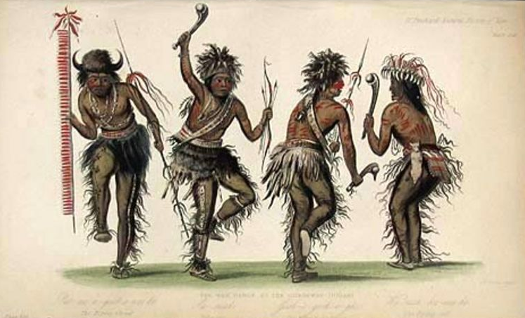

Figure 2: “The War Dance by Ojibbeway Indians” (1855) by George Catlin.

This was not the only time Dickens revealed a superior and mistrustful attitude towards the American Indians. His capacity for racial intolerance was clearly demonstrated during the Indian Mutiny massacres of 1857. “Every day,” argues Lillian Nayder, “accounts of Indian atrocities and examples of British martyrdom were reported in the British press: the sale of Englishwomen to Indians in the streets of Cawnpore, for example [Examiner (5 September 1857)]. Predictably enough, these accounts elicited calls for repression and retribution.”² “The Perils of Certain English Prisoners” is a timely story Dickens coauthored with Collins soon after the Mutiny and his son Walter’s departure for India with a cadetship obtained with the help of the wealthy philanthropist Angela Burdett-Coutts. The story voices the dominant view of the middle classes, whose powerful influence on public opinion fostered an almost universal demand for bloody revenge against the mutineers. Although the setting of the story is shifted to Belize (formerly British Honduras, Central America), it is unmistakably a product of the colonialist mindset in which a supposedly civilizing center interacts one-sidedly with a periphery of supposed inferiors.
Dickens was a regular contributor to the radical intellectual journal Examiner, which played a significant role in the development of racist ideas in the Victorian era. He wrote in a private letter to Burdett-Coutts a month after the Examiner had reported the Indian atrocities:

I wish I were Commander in Chief in India. The first thing I would do to strike that Oriental race with amazement [. . .] should be to proclaim to them, in their language, that I considered my holding that appointment by the leave of God, to mean that I should do my utmost to exterminate the Race upon whom the stain of the late cruelties rested [. . .] to blot it out of mankind and raze it off the face of the Earth. (To Miss Burdett Coutts, 4 October 1857, Pilgrim, 8: 459)

Some of Dickens’s journalistic writings, not least in the Examiner and Household Words, suggest the operation of a form of political unconscious with regard to race. Dickens took a side in the complex interaction between the colonialist center and its notional margins, and in that respect he participated in a culture of aggressive self-deception. The middle classes would attempt to assuage their insecurity and guilt about otherness by interpreting the actions, manners, and customs of those others, strange and incomprehensible to them, as manifestations of a dangerous madness that needed to be dominated and controlled.
Dickens’s racism, it appears, remained little moderated up to his death and was even hardened by the Jamaica uprising of 1865 (Figure 3). Witness, for example, Rev. Luke Honeythunder in The Mystery of Edwin Drood, the hypocritical London philanthropist and guardian of the Landless twins, “beautiful barbaric captives brought from some wild tropical dominion”; he calls aloud to his fellow-creatures “to abolish military force, but [. . .] first to bring all commanding officers who had done their duty, to trial by court-martial for that offence, and shoot them” (MED, ch. 6). Dickens modeled Honeythunder on the radical reform politician John Bright, member of the Jamaica Committee that demanded Governor Eyre’s trial for the killing of many black peasants and the hanging of George William Gordon, the instigator of the so-called rebellion. Meanwhile, Dickens supported the Eyre Defense Committee along with the more overtly racist Thomas Carlyle and John Ruskin.
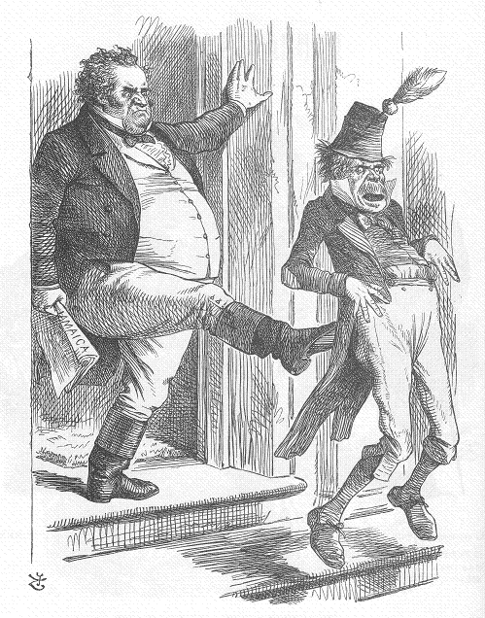
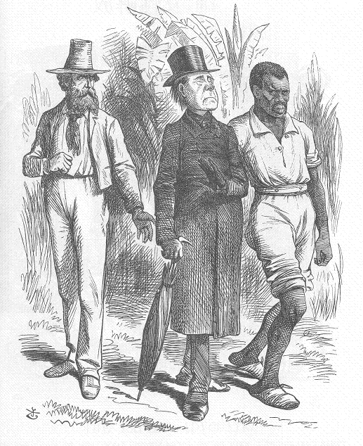

Figure 3: (Left) Rebellion Had Bad Luck: John Bull. “There, get out! Don’t let me see your ugly face again for twenty years, and thank your stars you were stopped in time!” (Punch, 16 December 1865). (Right) The Jamaica Question: White Planter. “Am not I a man and a brother, too, Mr. Stiggins?” (Punch, 23 December 1865)

In Our Mutual Friend, the lower middle-class clerk R. Wilfer describes black African kings as “cheap” and “nasty” (OMF, bk. 2, ch. 14) in the course of trying to prove to John Harmon the affectionate nature of his daughter Bella. This father is possessed by the centripetal forces of colonialism, much like Mr. Meagles and his creator Dickens, both of whom are just within the confines of middle-class gentility. In that sense, and reflecting Dickens’s own deep-seated aversion to middle-class women’s extra-domestic activities, it is not surprising to find that Bella, who initially wishes to marry for mercenary motives and strays beyond the ideological boundaries of Victorian femininity, should be portrayed as finally growing in character until she is rehabilitated within the private sphere as an “Angel in the House”.⁴ The aggressive insularity, driven by a profound uneasiness when confronted with otherness, would necessitate the enforcement of gender boundaries along with the racial. Indeed the two are conflated in the satirical presentation of Mrs. Jellyby (Figure 4), a telescopic philanthropist who, ignoring her very large family, “could see nothing nearer than Africa” (BH, ch. 4). By the time of Bleak House, as Grace Moore puts it, “Dickens’s frustration with the policy of domestic laissez-faire-in his view a euphemism for downright negligence-had become so overwhelming that he could only envisage the British nation as Mrs Jellyby’s home, and the dispossessed as analogous to her disregarded children.”⁵ Through Mrs. Jellyby, Dickens argues that the love of humanity, whether philanthropy or charity, should first be practiced at home.
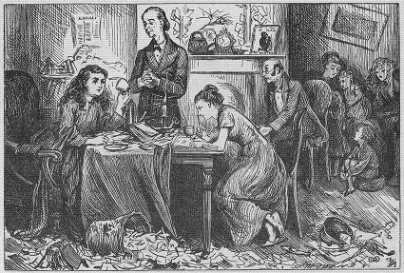

Figure 4: “We hope by this time next year to have from a hundred and fifty to two hundred healthy families cultivating coffee and educating the natives of Borrioboola-Gha, on the left bank of the Niger.” Illustrated by Fred Barnard (Household Edition, BH, ch. 4).

The sense of charity with which Dickens is often identified does appear to have gradually waned through his later works, where his discourse is imbued with elements of anti-feminism and racism. Ironically, then, although he could be rather liberal about the definition and confinement of madness, Dickens was eventually less progressive concerning the marginalization of both women and colonized people as inferiors. Ultimately, while a sense of Christian charity was personified, especially in his earlier works, through memorable characters such as Mr. Pickwick and the reformed Scrooge, it seems not to have been a sentiment he would extend to all people for all time; it was a benevolence hedged with limitations and exceptions.

______________________
¹ Maria K. Bachman, “‘Furious Passions of the Celtic Race’: Ireland, Madness and Wilkie Collins’s Blind Love,” Victorian Crime, Madness and Sensation, ed. Andrew Maunder and Grace Moore (Aldershot: Ashgate, 2004) 179.
² Lillian Nayder, Unequal Partners: Charles Dickens, Wilkie Collins, & Victorian Authorship [Ithaca: Cornell UP, 2002] 100-01.
³ Sabine Clemm, Dickens, Journalism, and Nationhood: Mapping the World in Household Words (New York: Routledge, 2009) 82.
⁴ Mrs. Wilfer visits Bella and John in their new home and leads the way through the whole of the interior decorations in an arctic mood, “with the bearing of a Savage Chief, who would feel himself compromised by manifesting the slightest token of surprise or admiration” (OMF, bk. 4, chap. 16). The middle classes in Victorian Britain and the savage chiefs abroad are accepted as being close enough with their emphasis on the values of respectability.
⁵ Grace Moore, Dickens and Empire: Discourses of Class, Race and Colonialism in the Works of Charles Dickens (Aldershot: Ashgate, 2004) 36.

